Solve the following linear systems
- (7-3ex3) 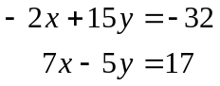
- (7-3ex5) 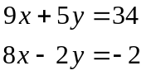
- (7-2ex1) !DO NOT DO THIS PROBLEM! 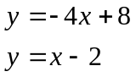
- (7-2ex2) !DO NOT DO THIS PROBLEM! 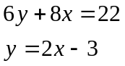
- (7-3ex1) !DO NOT DO THIS PROBLEM! 